ST GEORGE THE MARTYR CHARITY
WINTER NEWSLETTER 2017
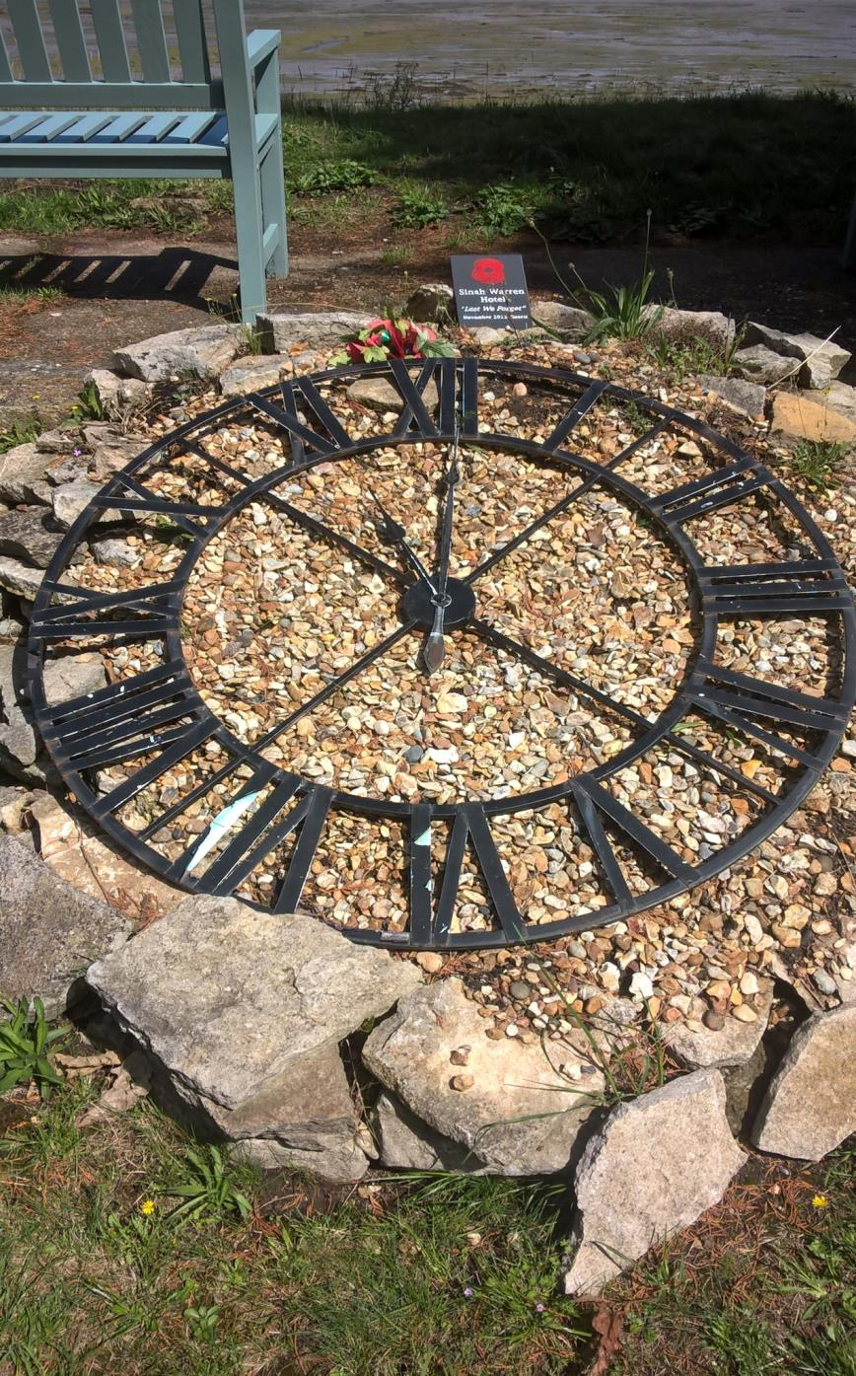
Clerk’s Comments

As always I like to start with the good news, which is that your pensions will be in your bank account by 15th November. If you have not received the money by say 20th please let me know.
Now for the bad news!! I have decided to retire at the end of March 2018. I have been pondering this decision for some time and by then will be 64. The job is great - the best I ever had and the people are great - both Annie and I will miss you. I have enjoyed my time here and Annie and I have had good times on the holidays but we want to do other things, see more places and enjoy longer holidays. We are busy looking for my replacement and we will hopefully appoint in time to introduce my successor to you in the next newsletter.
Many of you will know that I suffered a heart attack in August. This came as enormous shock to me because I felt healthy and fit, do not smoke and have a reasonable diet. Fortunately the NHS was wonderful and I had a stent put in within an hour of calling 111, which is amazing. I am now back full time, I feel fine and expect to get back to cycling and running by Christmas. I look forward to seeing many of you on the outings and on the holiday in the run up to Christmas.
Thank you for all your messages of goodwill and cards. It was lovely to receive them. I don’t think I have ever had so many in my life. The heart attack did not influence my decision to retire but it did send a message loud and clear that I need to get on with all the things that Annie and I want to do.
My last event will probably be at the pantomime at Brick lane on Tuesday 27th February. Aladdin. So see you there. Oh know you won’t!!!

VISITORS VIEW RECENT EVENTS
RECENT EVENTS

I hope everyone had a good Summer! At the start of the Summer Season we did a trip to Canterbury and Hastings. This was followed by our annual holiday to Sinah Warren in Hayling Island and to the Littlecote House Hotel in Berkshire. On each holiday we did a total of three coach trips out and from Sinah Warren we went on a trip to Salisbury, Chichester and a drive around the New Forest where we were able to see many of the native New Forest Ponies. Whilst at Sinah Warren we were treated to a great night of entertainment with the appearance of Jane McDonald which was a pleasant bonus that we weren’t expecting!

Unfortunately Paul wasn’t able to come on the second holiday due to illness and we were lucky that Sarah was able to step in at the last moment and help us out. Littlecote House was a treat for those of us who enjoy history although none of us got to see the ghost! The 3 trips that we went on from here included historic Oxford, Bath and a lovely Canal trip with informative and enthusiastic volunteers from the Kennet and Avon Canal Trust. I think that you we all agree that they looked after us very well.

Coming up we have the Cinema trip to the Ritzy. Should this be a success it could be something we could arrange on a regular basis provided that we have adequate numbers. I would appreciate any feedback that you may have.

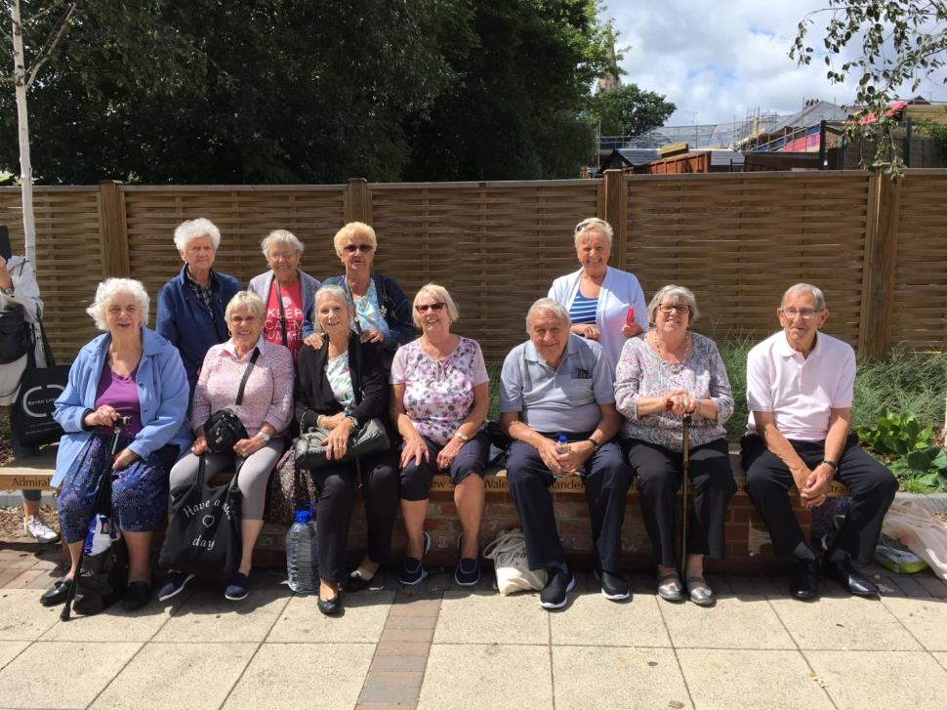

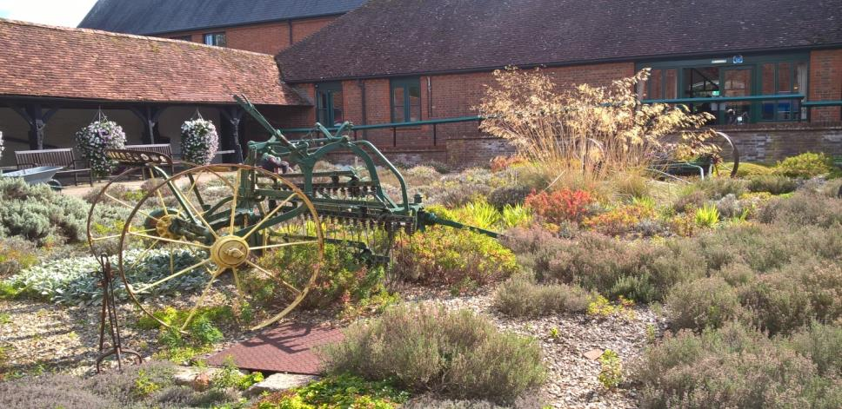

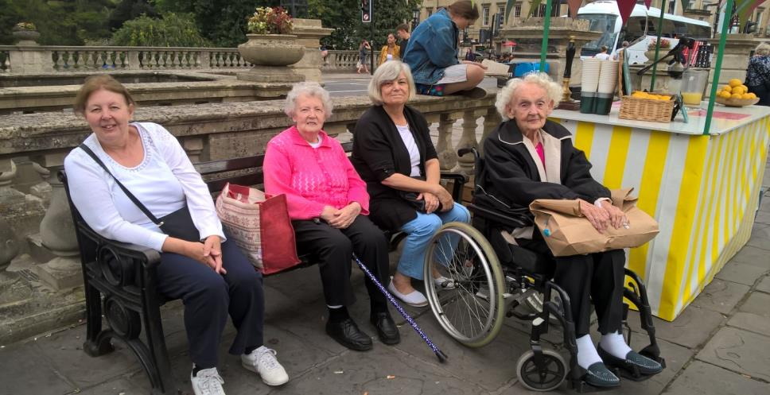

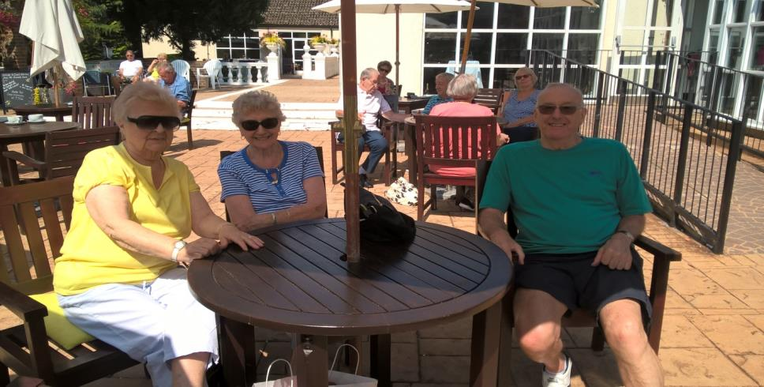

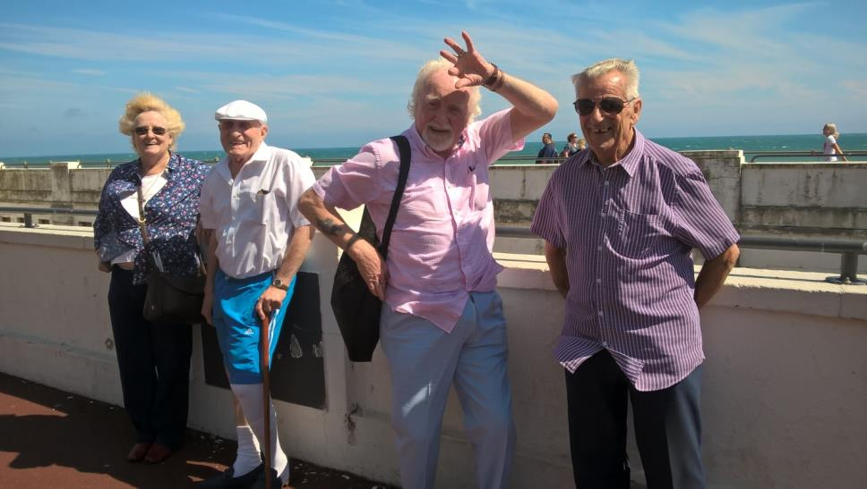

CHAIRMAN’S CORNER

The nights are drawing in and autumn leaves are falling, so do be careful when you are out and about walking on wet leaves on the pavements.

This is also the time to get your influenza vaccination from your GP surgeries drop in clinic.

When I was researching the history of London Bridge for my history column in the Chamber of Commerce magazine I discovered that from the time the Romans built the first wooden bridge in AD55, London Bridge was the only bridge over the River Thames in central London until 1729. On the next page is an artist’s impression of Southwark and the first Roman Bridge in the second century, which was a series of islands in the Thames Tidal flood marshes.
Today there 19 Road bridges 7 Railway bridges and 5 Pedestrian bridges in London.

Ken Hayes
Chairman

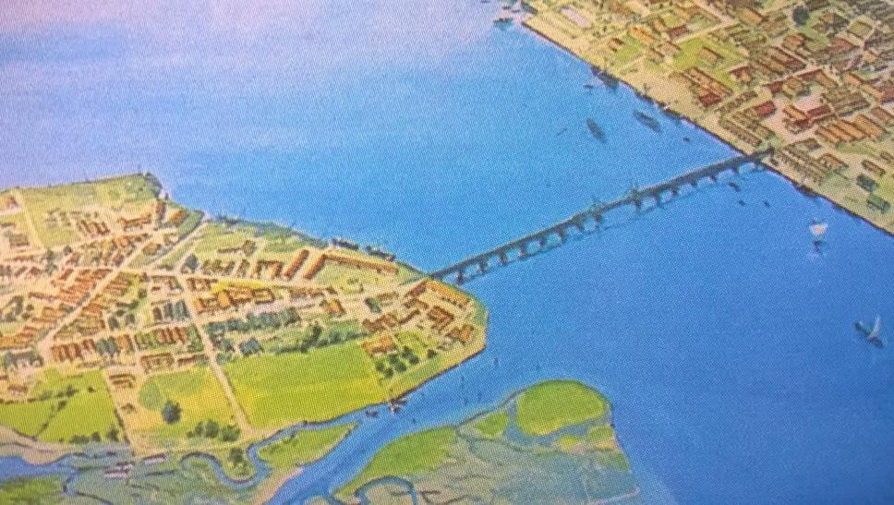

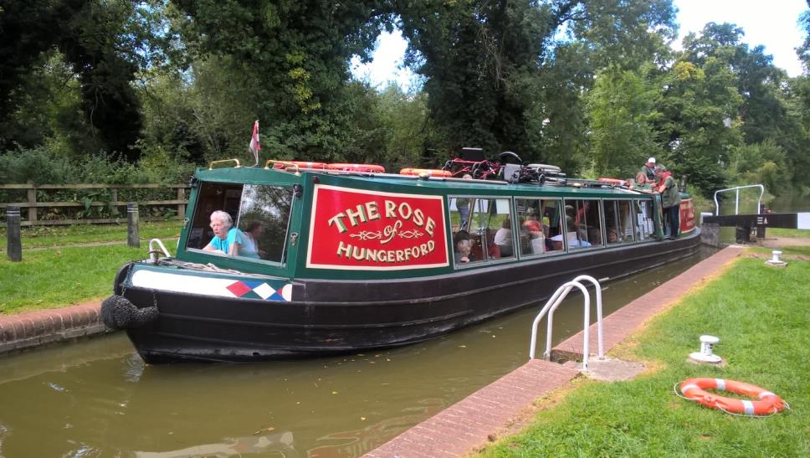

EVERYONE’S ACTIVE
One of our members has been going to ‘The Castle Centre ’with the scheme Everyone’s Active’ and found it extremely beneficial. Give it a go! They will tailor the gym sessions to whatever health needs you may have.
Southwark borough residents are now able to use the swim and gym facilities for free in six of the borough’s leisure centres, operated by Everyone Active in partnership with Southwark Council. Registration is now open for Free Swim and Gym.
When is the offer available?
- Anytime on Friday (subject to programmes and timetables)
- Saturday and Sunday afternoons from 2.00pm to close
- Over 60s can take part in any Silver sessions free
- Disabled residents will be able to use all leisure centres for free seven days a week
Southwark Council believe the best way to be proactive about health and wellbeing is by prevention, by making it easier for people to make healthier choices and to achieve a more active lifestyle.
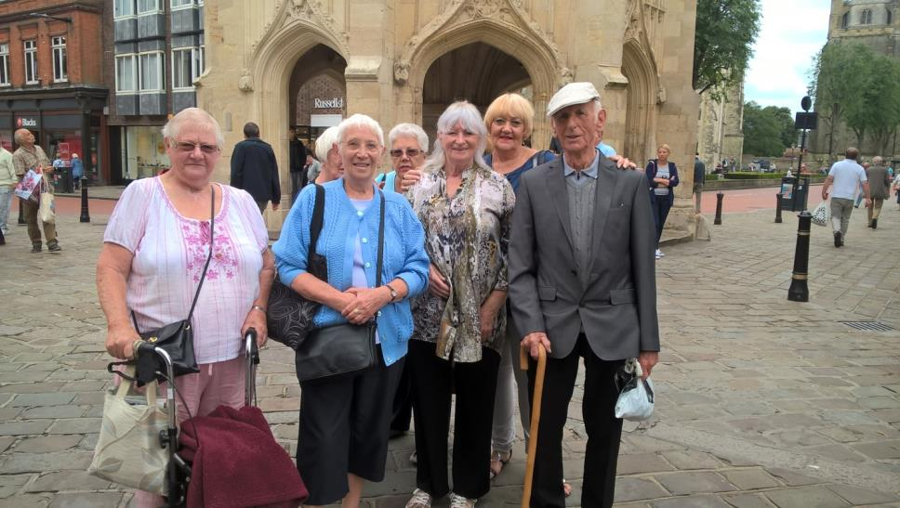

Happy Bus Pass Outings October 2017

This is a friendly informal group of older people not a formal organisation. People come at their own risk and must be able to look after themselves. New people welcome.

To attend an outing all you need to do is be at Waterloo Action Centre, 14 Baylis Rd, SE1 7AA by 11am on a Wednesday. All places visited are free so there should be no cost for any outing, provided you bring your Freedom Pass. It is suggested you bring sandwiches as the group find somewhere to eat them together.

October | 25 | Charlton House Greenwich. Jacobean country House. All rooms will be available to view as well as gardens and tea room
November | 1 | Migration Museum and London Fire Brigade Pop-up Museum.
 | 8 | Mall Galleries,SW1: British Wildlife Photography Awards 2017 (National Gallery, National Portrait Gallery 5 mins away)
 | 15 | The Museum of Methodism and John Wesley’s House. The Museum of Methodism tells the history of Methodism from John Wesley to the present day and its contribution to shaping Britain’s political and social history. John Wesley’s House stands next to the chapel. It was his home for over a decade, and is one of the finest surviving small Georgian townhouses in London.
 | 22 | The Horniman Museum and Gardens
 | 29 | Geffrye Museum  (museum will close on 7 January 2018 for almost two years)
December | 6 | Hyde Park Winter Wonderland
 | 13 | National Army Museum  The National Army Museum is the British Army’s central museum. Having reopened in March 2017 following a major £23.75 million re-development project including £11.5m from the Heritage Lottery Fund, the museum houses five galleries that cover British military history from the English Civil War up to modern day.
 | 20 | British Library and Wellcome Collection.  (also nearby The Petrie Museum of Egyptian Archaeology and Grant Museum of Zoology)
 | 27 | All Hallows by the Tower and Crypt Museum and St Dunstan in the East.  All Hallows by the Tower is the oldest church in the City of London and was founded by the Abbey of Barking in 675AD, 300 years before the Tower of London. In the crypt beneath is a second century Roman pavement, discovered in 1926, evidence of city life on this site for nearly two thousand years.

If you cannot come on these outings but would like to be involved in the future please leave your contact details for Jenny at WAC. Tel no 0207 261 1404 or jennystileswac@gmail.co

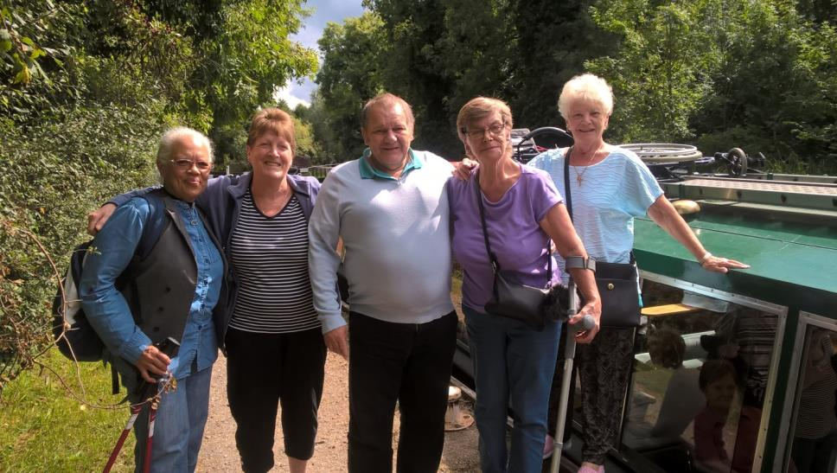

Dates for Diaries
Saturday 4th November Free
Regent Street Motor Show. 10.30-4pm. Vehicles go on display in the famous shopping street. This is the largest free Motor Show in the UK including classis and futuristic vehicles.
Sunday 5Th November Free
Southwark Fireworks Display. South Bank of the River Thames. Tickets for the event are free for Southwark residents but must be booked in advance.
Sunday 5th November
London to Brighton Veteran Car Run at Westminster Bridge. See 500+ veteran cars-up to 120 years old cross Westminster Bridge.
Saturday 11th November Free
The Lord Mayor’s Show. This is a spectacular procession between Bank and Aldwych. 11am-2.30pm. Fireworks display at 5pm at River Thames.
Saturday 11th November
Remembrance in London. Silence in the square in Trafalgar Square 11am.
Sunday 12th November
Remembrance Sunday Service and parade at the Cenotaph in Whitechapel
Over Christmas/New Year Season
Southbank Centre Christmas Market. Market lines the south Bank of the Thames
Friday 1st December to Sunday 3rd December
Christmas Market at Southwark Cathedral organised by the Friends of Southwark Cathedral.
Monday 11th December to 22nd December Free
Christmas Carols in Trafalgar Square. 40 Carol groups each sing for an hour beneath the Trafalgar Square Christmas Tree.These free Christmas Carol Concerts raise funds for voluntary and charitable organisations. Performances take place between 4pm and 8pm on weekdays and between 2pm and 6pm on weekends. No performances on 12th and 16th December.
Monday 1st January 2018
New Years Day Parade. More than 10,000 performers parade along the streets of Central London. Runs from Green Park Tube Station at 12pm to Parliament Square via Piccadilly Circus, lower regent street, Pall Mall, Trafalgar Square and Whitehall. Finish at around 3.30pm.

Check out our website at www.stgeorgethemartyrcharity.com
We have added the newsletter and lots more photos.

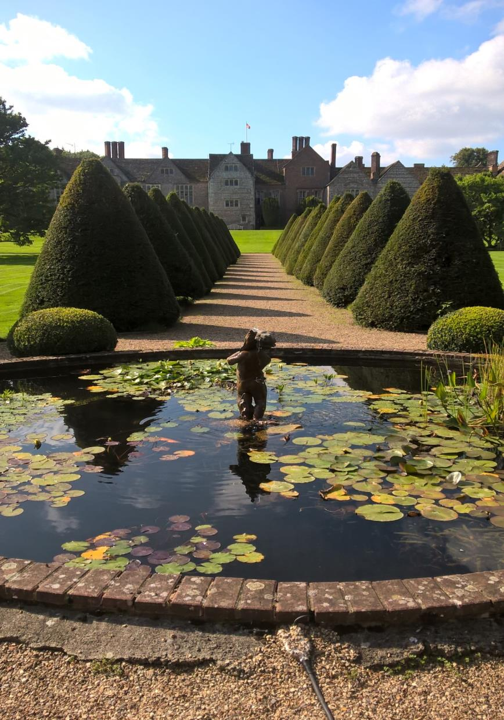

St. George the Martyr Charity
(Registered Charity No. 208732)

Marshall House, 66 Newcomen Street London SE1 1YT
Tel: 020 7407 2994 Mobile: 07967 770 652 Email: clerk@stgeorge1584.org.uk
www.stgeorgethemartyrcharity.com

