ST GEORGE THE MARTYR CHARITY
SPRING NEWSLETTER 2017

Clerk’s Comments
Please look out for your pension which will be paid into your account by 15th March. If you do not receive it after that date just let me know so l can sort out any problem.
With this newsletter is a sheet with information about our forthcoming outings. Please complete and return by 17th March. Make sure you read it all the way through as we have also added a question at the bottom concerning future holidays.

The seaside hotels are very popular with all of you but the downside is that the only suitable Warners resort is Hayling Island. They also have some chalet-only resorts, which I know are not popular with many of you.
Benbridge on the Isle of Wight is now difficult to get to because the ferry company insist that everyone gets off the coach before boarding and goes to the upper deck. This creates a problem because we have a fair number needing the lift and assistance. The other choice with Warners is to go to one of their country hotels where there are six to choose from. Depending on demand we could take more people to one of these hotels and a smaller number to Hayling Island in 2018.

Can you please answer the questions at the bottom of the form which will give us an idea of the demand for each holiday so we can book for next year.

RECENT EVENTS

We enjoyed two theatre trips at the end of the year with the particularly popular ‘Motown the Musical’ which had many of you up on your feet and ‘The Curious Incident of the dog in the Night’. This was followed shortly afterwards by the winter break at Holme Lacy where we all managed to survive the cold and enjoyed Christmas to New Year at record speed.

Pub lunches and shopping trips were arranged at Burreta’s where we always have good food and this year visited the Newham Court Shopping Village in Maidstone with a pub lunch at The Chiltern Hundreds.

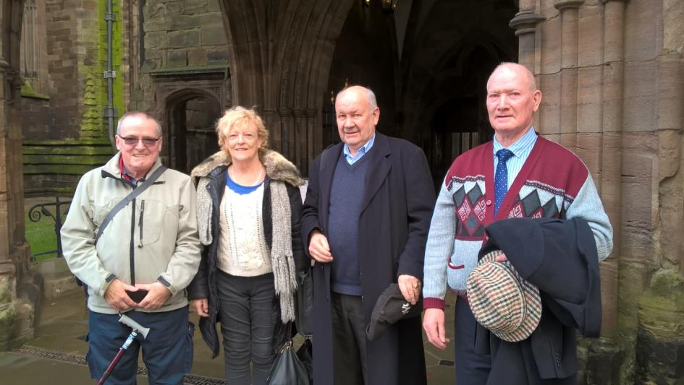

The Bricklane Pantomime yet again didn’t disappoint and we have received an enormous amount of feedback from our members about what a great time they had and many seemed to feel that it had been the best show yet. It is lovely to go to an event where many of the charity members are present and enjoy the time all together. We look forward to going again next year!
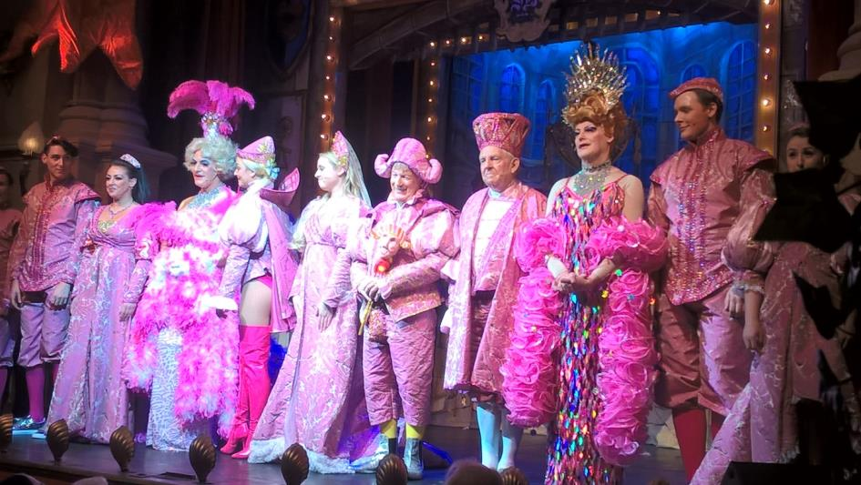

CHAIRMAN’S CORNER

I hope that you all had a good Christmas and have managed to keep warm during the cold weather in the new year.
It was good to see all of you who came to the Winter Party at Brick Lane Music Hall. A good laugh and a sing along does us all good.
We have lots of outings and theatre trips planned for the coming Spring, Summer and Autumn in addition to the two holidays for you to go on.
Please do let the office know if you are unable to go on an outing or holiday as soon as you can so we can offer your place to someone else.
As the poet Percy Shelly wrote. “ O wind if Winter comes can Spring be far behind”.

Ken Hayes

INFORMATION ON SILVERFIT

For those of you who are interested in keeping fit and improving their health you may find the following information useful. A few members of our charity already attend local events and feel they have benefited.

Silverfit is a small charity who want to raise the awareness of the benefit of exercise for the over 50’s. They run leisure activities especially for the over 50’s and provide information and advice on their web site www.silverfit.org.uk

SILVER TUESDAY
Currently in our area a gym session is held at the Academy of Sport (AOS) near The Elephant and Castle, 100-116 London Road, SE1 6LN at 9.30-10.30am in the Indoor Gym every Tuesday morning.
Cost £1 for members and £2.50 per session for non members.
Membership is £5 per annum and can be paid on the day.

SILVER MONDAY
Held at Southwark Park, 100 Clements Road, SE16 4DG. The meeting point is the Community Hall at 100 Clements Road at 1pm with a 1.30pm start of the activities.
This session is held every Monday afternoon and you can choose between Nordic Walking with Francesca ( Poles will be provided) or T’ai Chi with Sareera.

Afterwards there are refreshments at 2.30pm.
Cost £1 for members and £2.50 for non members.

Silverfit can be contacted in the following ways:

General enquiries: info@silverfit.org.uk or 07721 419 518.
Website:susanne@silverfit.org.uk or by post:
Silverfit, PO Box 64609 SW8 9AW London UK

Happy Bus Pass Outings March 2017

This is a friendly informal group of older people not a formal organisation. People come at their own risk and must be able to look after themselves. New people welcome.

To attend an outing all you need to do is be at Waterloo Action Centre, 14 Baylis Rd, SE1 7AA by 11am on a Weds. All places visited are free so there should be no cost for any outing, provided you bring your Freedom Pass. It is suggested you bring sandwiches as the group find somewhere to eat them together.

March | 8 | The Charter House .Museum,gardens,café. Founded 1348. Free
 | 15 | Science Museum. Five floors covering different aspects of technology and science using displays and interactive information.
 | 22 | National Gallery/National Portrait Gallery  The National Gallery displays more than 2,000 Western European paintings from the middle ages to the 20th century.  The National Portrait Gallery is an art gallery in London housing a collection of portraits of historically import and famous people.
 | 29 | Fulham Palace  Discover over 1300 years of British history at the historic house and garden of the Bishop of London.

If you cannot come on these outings but would like to be involved in the future please leave your contact details for Jenny at WAC. Tel no 0207 261 1404 or jennystileswac@gmail.co

Dates for Diaries

Saturday 11th March 2017
17.30 Winsor School Concert Band, Chamber Choir, Senior Jazz Band and Vocal Jazz choir at Southwark Cathedral

Tuesday 21st March 2017
Bakerloo Line Extension Consultation Exhibition at East Street Library. Find out more about the plans.

3.15pm Music Recital by students of the Royal Academy of Music Southwark Cathedral

13th 14th 15th 16th April 2017
ROYAL GREENWICH TALL SHIPS
A huge Parade of Sail sees around 30 Tall Ships sail down the Thames in convoy on the Sunday of the Tall Ships Festival which runs over the Easter weekend, from Thursday 13th to Sunday 16th April 2017. This year, the festival forms part of the Canadian Confederation 150th anniversary celebrations, with ships sailing from Greenwich to Quebec, passing through Sines, Portugal, the Canary Islands, Bermuda and Boston. Over the five days there will be a series of activities in Greenwich, Woolwich and on the River Thames while on Sunday 16th April ships, street performers and a grand fireworks finale will take place.

Tuesday 18th April 2017 13.30
Celebrate Africa-The Mzansi Youth Choir
Mzansi presents a sensational blend of exquisite, youthful sounds and vibrant energy.

Sunday 23rd April 2017
LONDON MARATHON
The race kicks off at Greenwich Park and Blackheath with a loop around Charlton and Woolwich, continues through Rotherhithe and Bermondsey, crosses the Thames on Tower Bridge before circling Canary Wharf and the City ahead of the showpiece finish along the Embankment, past Parliament Square and onto The Mall in the shadow of Buckingham Palace.

Saturday 15th July 2017
Mint Street Music festival
Free family-friendly music festival

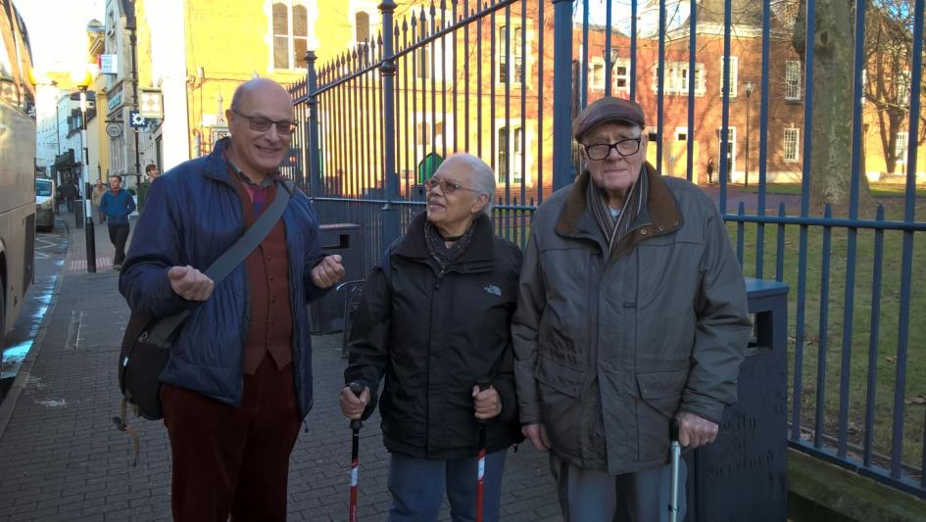

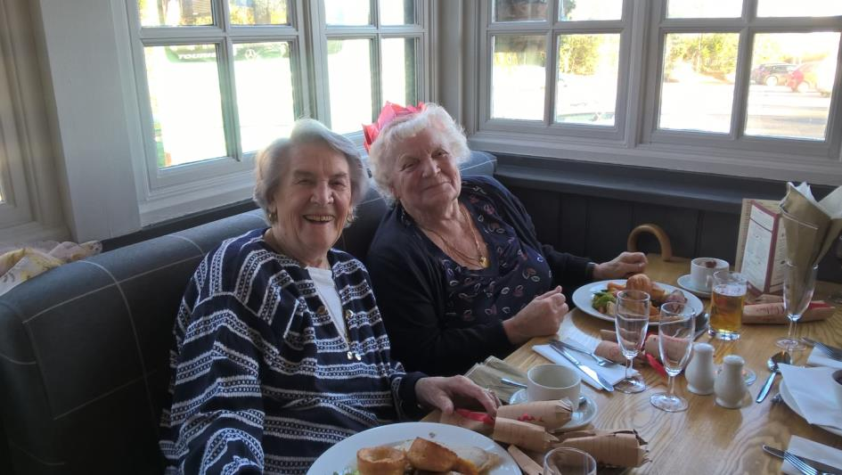

St. George the Martyr Charity
(Registered Charity No. 208732)

Marshall House, 66 Newcomen Street London SE1 1YT
Tel: 020 7407 2994 Mobile: 07967 770 652 Email: clerk@stgeorge1584.org.uk

